***YashwantroaChavan School Of Rural Development ShivajiUniversity ,Kolhapur***

***Name : onkar Rajendra Charate***

***Class : MCA 1 (Sem 1)***

***Roll no : 35***

***Subject : Python Programming***

Index

|  |  |  |  |  |
| --- | --- | --- | --- | --- |
| **Sr. no.** | **Title of the program** | | **Date** | **Sign** |
| **1** | **Write a python program to accept three numbers and find the greatest and print the result.** | |  |  |
| **2** | **Write a python program to check input year is leap year or not.** | |  |  |
| **3** | **Write a program to reverse a string and check if it is palindrome using slicing (::-1) and without using slicing.** | |  |  |
| **4** | **Write a program to check whether input number is prime or not.** | |  |  |
| **5** | **Write a program to find the sum of digits of given number, reverse the number and check if it is palindrome.** | |  |  |
| **6** | **Write a program to perform simulation of simple calculator for basic operations like +, -, *, /, % etc. (Hint: Read a character +, - etc as operator from the user. Perform respective operation based on the operator. And Display the result)** | |  |  |
| **7** | **Write a python program to generate first ‘N’ Fibonacci numbers. The Fibonacci numbers are 0,1,1,2,3,5,8,13,21,34,…….where each number is the sum of preceding two.** | |  |  |
| **8** | **Write a python program that displays stars in right angled triangular form using nested loops.** | |  |  |
| **9** | **Write a python program to display class obtained by a student when percentage obtained will be given as input.** | |  |  |
| **10** | **Write a python program to count number of lines, words and characters in a text file.** | |  |  |
| **11** | **Write a python program to retrieve and display all rows from the employee table.** | |  |  |
| **12** | **Write a python program with user defined function to find factorial of given number.** | |  |  |
| **13** | **Consider the list operation.** | **qty=[5,4,7,3,6,2,1] and write the python code to perform the following** |  |  |
|  | **i)** | **Insert an element 9 at the beginning of the list** |  |  |
|  | **ii)** | **Insert an element 8 at the end of the list** |  |  |
|  | **iii)** | **Insert an element 7 at the index position 3 of the list** |  |  |
|  | **iv)** | **Delete an element at the beginning of the list** |  |  |
|  | **v)** | **Delete an element at the end of the list** |  |  |
|  | **vi)** | **Delete an element at the index position 4** |  |  |
|  | **vii)** | **Print the list in reverse order** |  |  |
|  | **viii)** | **Delete all the elements from the list** |  |  |
| **14** | **Create a dictionary for words and their meanings.**  **# Write functions to add a new entry (word: meaning) ,**  **# search for a particular word and retrieve meaning,**  **# given meaning find words with same meaning ,**  **# remove an entry, display all words sorted alphabetically. # [Program must be menu driven]** | |  |  |

***Qus1 :- Write a python program to accept three numbers and find the greatest and print the result.***

***Input :-***

a = int(input("Enter Valu Of A:"))

b = int(input("enter valu of B:"))

c = int(input("enter valu of C:"))

if (a >=b) and (a>=c):

                                        print("A IS Large")

elif (b >= a) and (b >=c):

                                        print("B IS Large")

elif (c >= a) and (c >= b):

                                        print("C IS Large")

else:

                                        print("ERROR Value Are String")

if(a==b==c):

                                        print("ALL NUMBERS ARE SAME")else:                                    print("Flot NO")

Output:

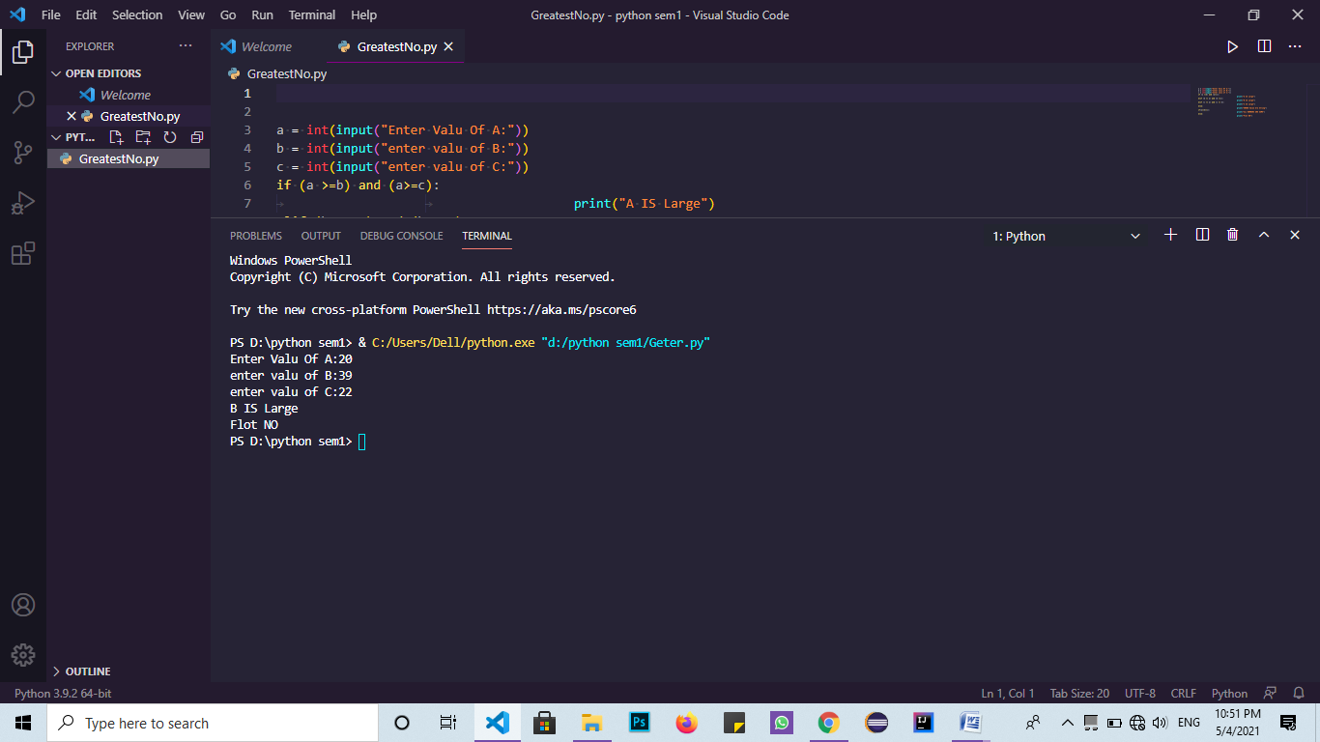

***Qus2 :- Write a python program to check input year is leap year or not.***

***Input :-***

year = int(input("Enter a year: "))

if (year % 4) == 0:

   if (year % 100) == 0:

       if (year % 400) == 0:

           print("{0} is a leap year".format(year))

       else:

           print("{0} is not a leap year".format(year))

   else:

       print("{0} is a leap year".format(year))

else:

   print("{0} is not a leap year".format(year))

Output:

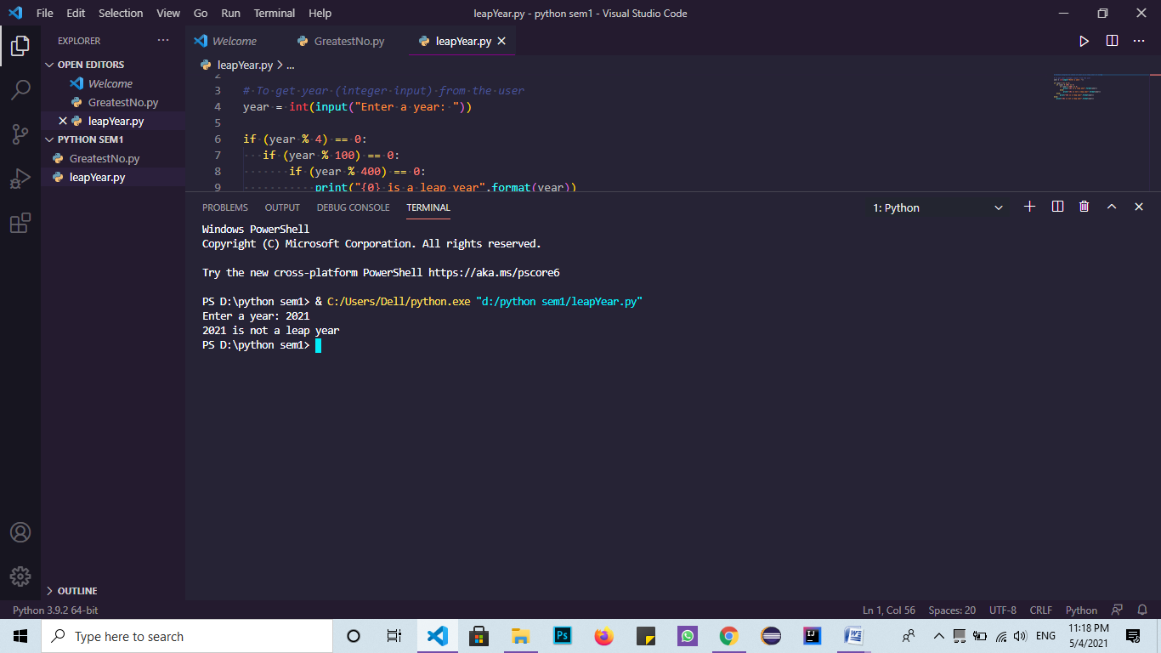

***Qus3 :- Write a program to reverse a string and check if it is palindrome using slicing (::-1)***

***Input1 :-***

my_string=input("Enter string:")

if(my_string==my_string[::-1]):

   print("The string is a palindrome")

else:

   print("The string isn't a palindrome")

Output: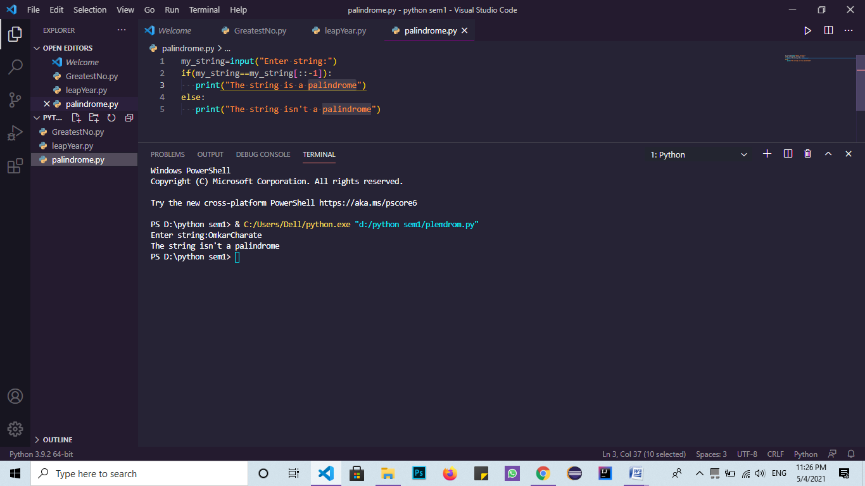

***Qus4 :- Write a program to check whether input number is prime or not.***

***Input :-***

num=int(input("Enter a number: "))

if num > 1:

   for i in range(2,num):

       if (num % i) == 0:

           print(num,"is not a prime number")

           print(i,"times",num//i,"is",num)

           break

   else:

       print(num,"is a prime number")

else:

   print(num,"is not a prime number")

output :

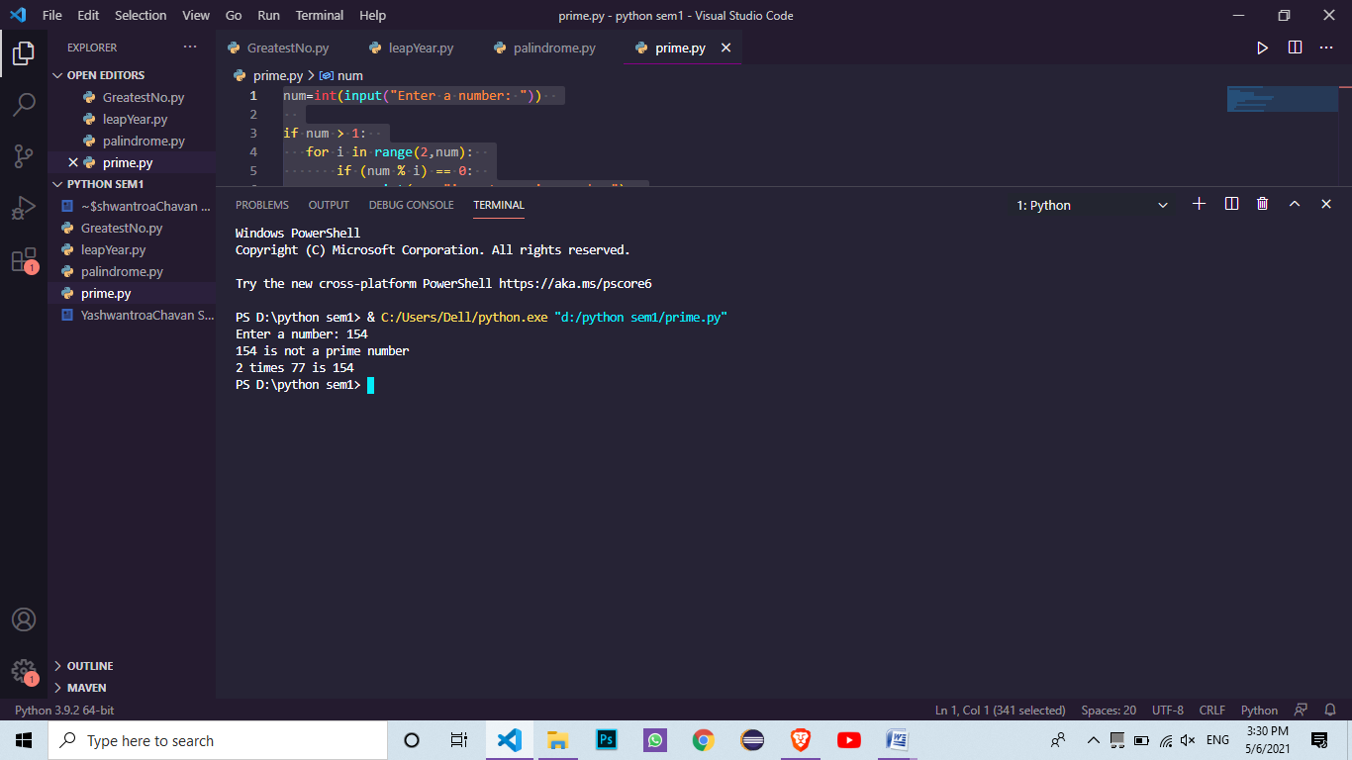

***Qus5 :- Write a program to find the sum of digits of given number, reverse the number and check if it is palindrome.***

***Input :-***

n=int(input("Enter number:"))

temp=n

rev=0

String_number =str(temp)

sum=rev=0

while(n>0):

    dig=n%10

    rev=rev*10+dig

    rem = n % 10

    sum=sum+rem

    n=n//10

print("the sum is ",sum)

if(temp==rev):

    print("The number is a palindrome!")

else:

    print("The number isn't a palindrome!")

Output:

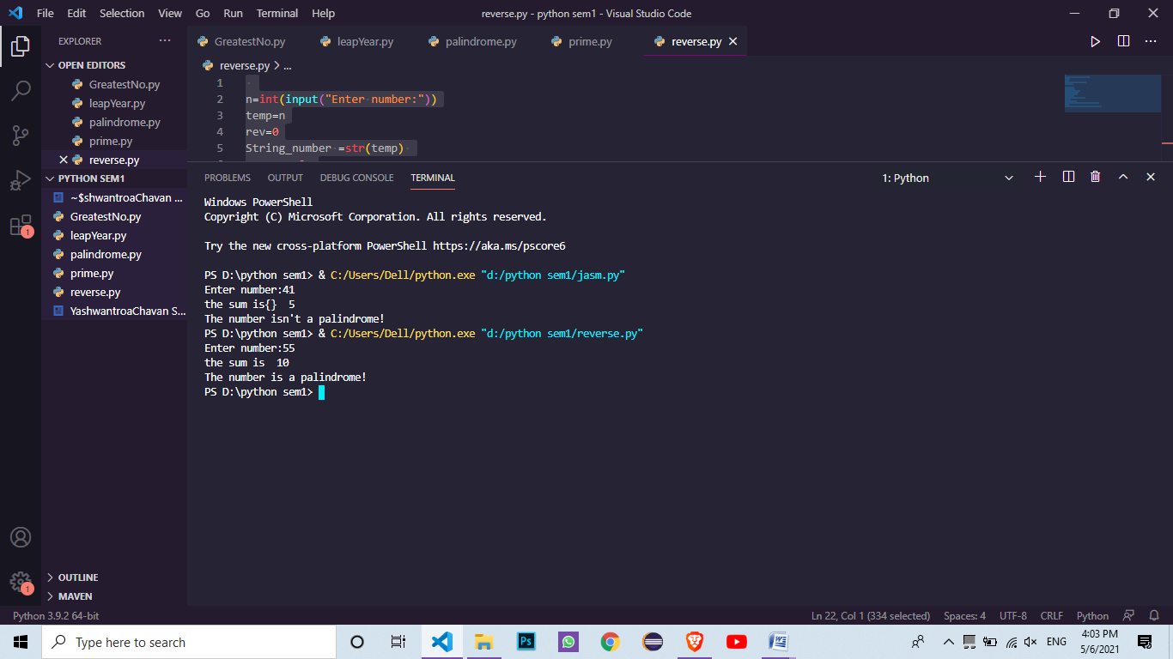

***Qus6 :- Write a program to perform simulation of simple calculator for basic operations like +,-,*,/,%etc,(Hint: Read a character +,-etc as operator from the user. Perform respective operation based on the operator. And Display the result).***

***Input :-***

def add(*x*, *y*):

    return x + y

def subtract(*x*, *y*):

    return x - y

def multiply(*x*, *y*):

    return x * y

def divide(*x*, *y*):

    return x / y

    print("Select operation.")

    print("1.Add")

    print("2.Subtract")

    print("3.Multiply")

    print("4.Divide")

while True:

    choice = input("Enter choice(1/2/3/4): ")

    if choice in ('1', '2', '3', '4'):

        num1 = float(input("Enter first number: "))

        num2 = float(input("Enter second number: "))

        if choice == '1':

            print(num1, "+", num2, "=", add(num1, num2))

        elif choice == '2':

            print(num1, "-", num2, "=", subtract(num1, num2))

        elif choice == '3':

            print(num1, "*", num2, "=", multiply(num1, num2))

        elif choice == '4':

            print(num1, "/", num2, "=", divide(num1, num2))

        break

    else:        print("Invalid Input")

Output:

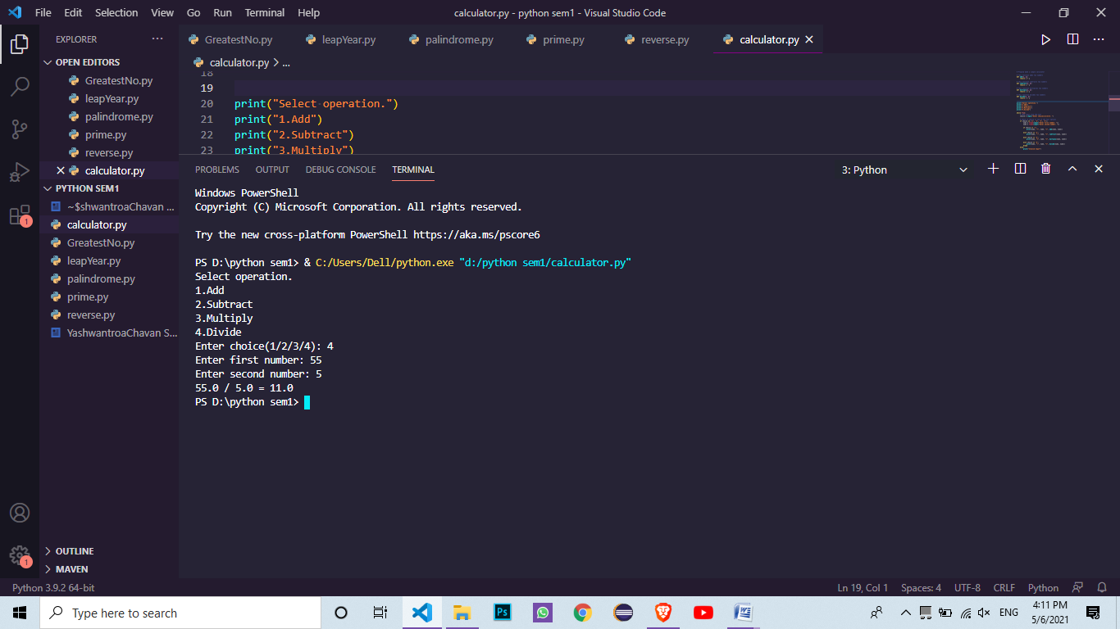

***Qus7 :- Write a python program to generate first ‘N’ Fibonacci numbers. The Fibonacci number are 0,1,1,2,3,5,8,13,21,34……..where each number is the sum of preceding two.***

***Input :-***

series_range=int(input("upto which number you want a series ?"))

f0=0

f1=1

print("series is :")

print(f0)

print(f1)

for i in range(0,series_range):

                    f2=f0+f1

                    f0=f1

                    f1=f2

                    print(f2)

Output:

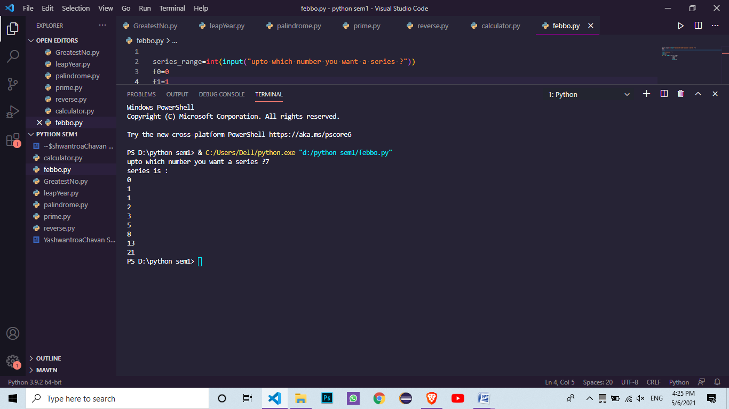

***Qus8 :- Write a python program that displays stars in right angled triangular form using nested loops.***

***Input :-***

n = int(input("Enter the number of rows"))

for i in range(0, n):

        for j in range(0, i + 1):

*# printing stars*

            print("* ", *end*="")

*# ending line after each row*

        print()

Output:

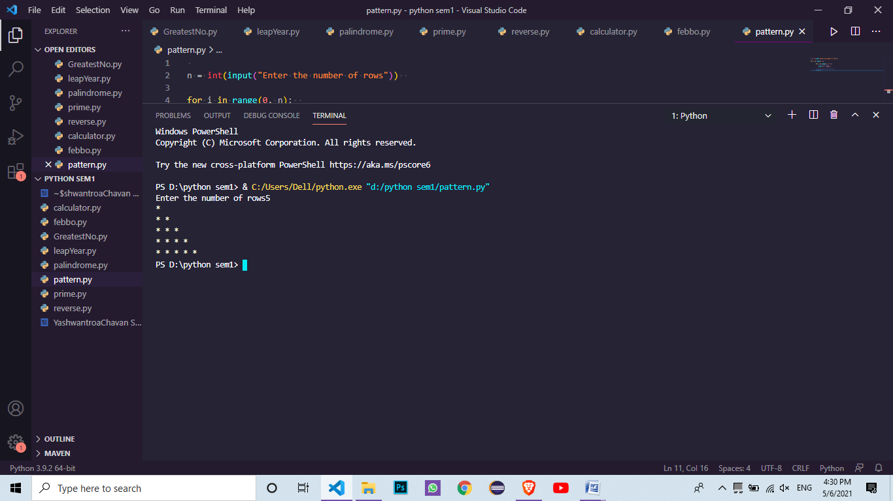

***Qus9 :- Write a python program to display class obtained by a student when percentage obtained will be given as input.***

***Input :-***

english = float(input(" Please enter English Marks: "))

math = float(input(" Please enter Math score: "))

computers = float(input(" Please enter Computer Marks: "))

physics = float(input(" Please enter Physics Marks: "))

chemistry = float(input(" Please enter Chemistry Marks: "))

total = english + math + computers + physics + chemistry

percentage = (total / 500) * 100

print("Total Marks = %.2f"  %total)

print("Marks Percentage = %.2f"  %percentage)

if(percentage >= 90):

    print("A Grade")

elif(percentage >= 80):

    print("B Grade")

elif(percentage >= 70):

    print("C Grade")

elif(percentage >= 60):

    print("D Grade")

elif(percentage >= 40):

    print("E Grade")

else:

    print("fail")

Output:

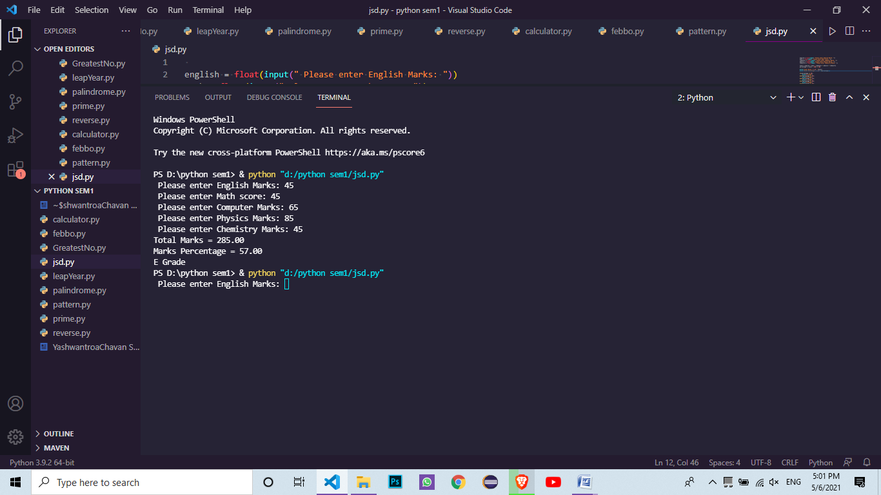

***Qus10 :- Write a python program to count number of lines , words and characters in a text file.***

***Input :-***

def counter(*fname*):

  num_words = 0

  num_lines = 0

  num_charc = 0

with open(fname, 'r') as f:

for line in f:

                    num_lines += 1

                    word = 'Y'

for letter in line:

                    if (letter != ' ' and word == 'Y')

                    num_words += 1

                    word = 'N'

elif (letter == ' '):

                    num_spaces += 1

                    word = 'Y'

for i in letter:r

                    if(i !=" " and i !="\n"):

                    num_charc += 1

                    print("Number of words in text file: ", num_words)

                    print("Number of lines in text file: ", num_lines)

                    print('Number of characters in text file: ', num_charc)

  if __name__ == '__main__':

                    fname = 'sample.txt'

                    try:

                                        counter(fname)

                    except:

                                        print('File not found')

Output:-

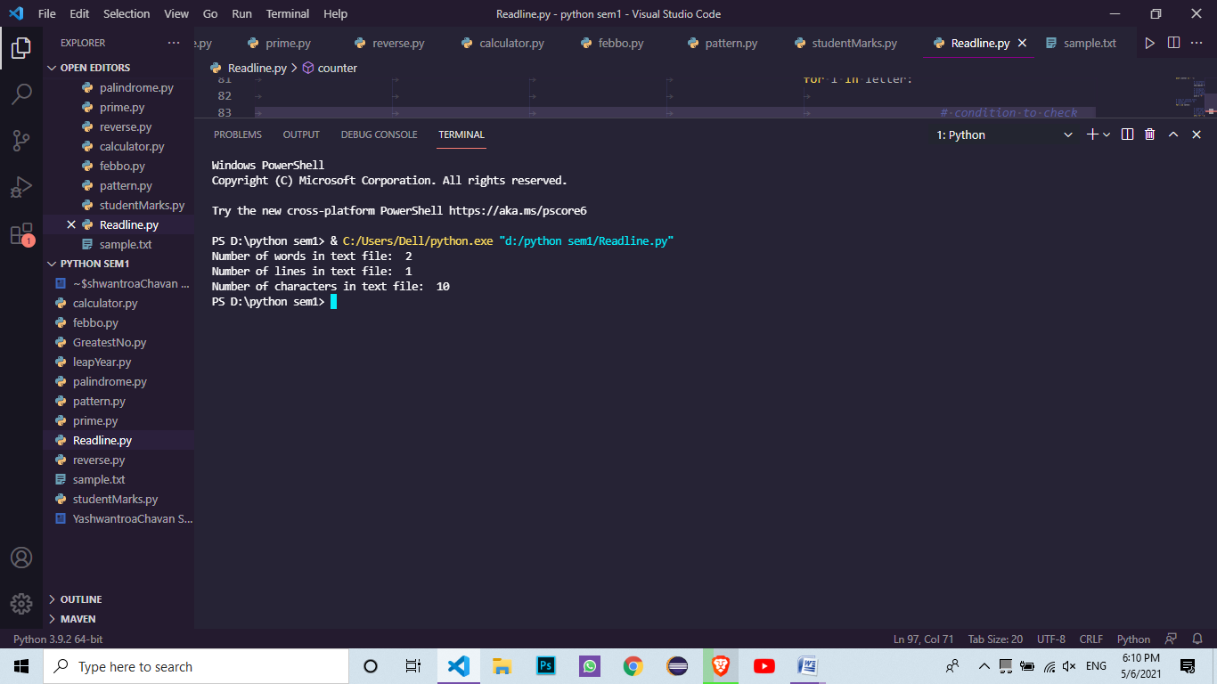

***Qus 11:- Write a python program to retrieve and display all rows from the employee table..***

***Input :-***

import sqlite3

from sqlite3 import Error

def sql_connection():

   try:

     conn = sqlite3.connect('mydatabase.db')

     return conn

   except Error:

     print(Error)

def sql_table(*conn*):

   cursorObj = conn.cursor()

*# Create the table*

   cursorObj.execute("CREATE TABLE salesman(salesman_id n(5), name char(30), city char(35), commission decimal(7,2));")

*# Insert records*

   cursorObj.executescript("""

   INSERT INTO salesman VALUES(5001,'James Hoog', 'New York', 0.15);

   INSERT INTO salesman VALUES(5002,'Nail Knite', 'Paris', 0.25);

   INSERT INTO salesman VALUES(5003,'Pit Alex', 'London', 0.15);

   INSERT INTO salesman VALUES(5004,'Mc Lyon', 'Paris', 0.35);

   INSERT INTO salesman VALUES(5005,'Paul Adam', 'Rome', 0.45);

   """)

   conn.commit()

   cursorObj.execute("SELECT * FROM salesman")

   rows = cursorObj.fetchall()

   print("Agent details:")

   for row in rows:

       print(row)

sqllite_conn = sql_connection()

sql_table(sqllite_conn)

if (sqllite_conn):

 sqllite_conn.close()

 print("\nThe SQLite connection is closed.")

Output:

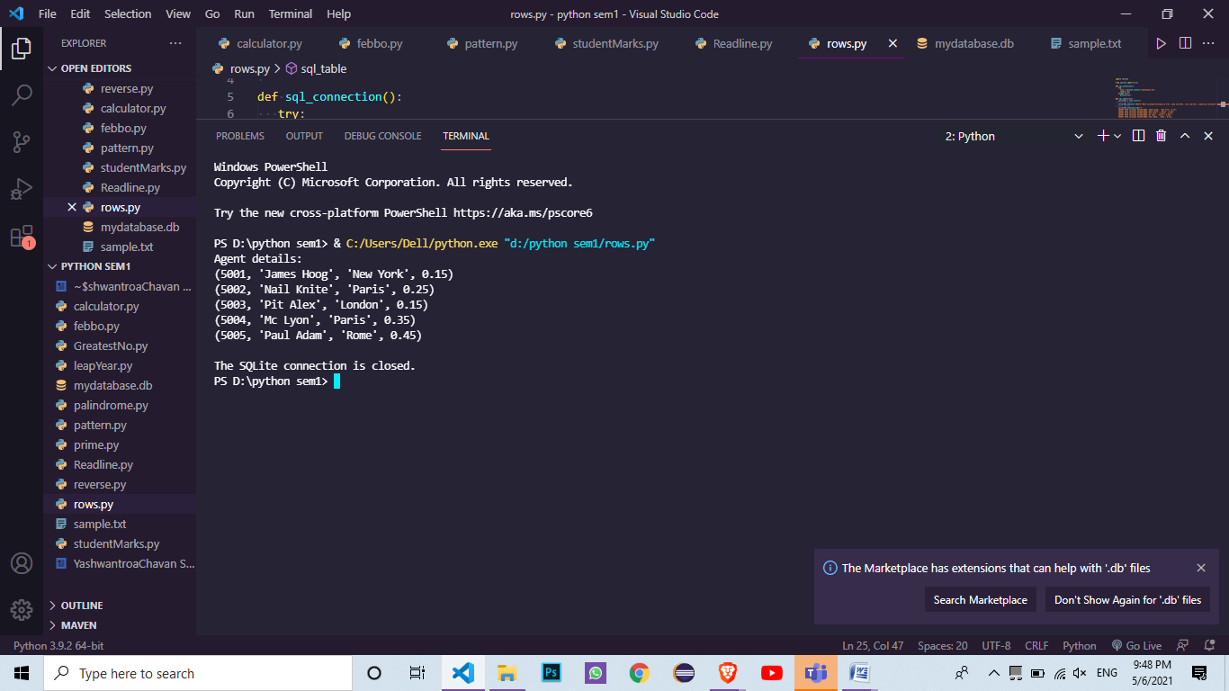

***Qus12 :- Write a python program with user defined function to find factorial of given number.***

***Input :-***

def factorial(*num*):

    fact=1

    for i in range(1, num+1):

        fact=fact*i

    return fact

number=int(input("Please enter any number to find factorial: "))

result=factorial(number)

print("The factorial of %d is = %d"%(number,result))

Output:

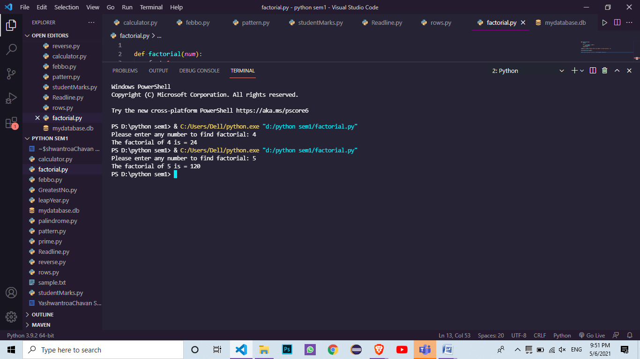

***Qus13:- Consider the list qty=[5,4,7,3,6,2,1] and write the python code to perform the following operation.***

* **Insert an element 9 at the beginning of the list**
* **Insert an element 8 at the end of the list**
* **Insert an element 7 at the index position 3 of the list**
* **Delete an element at the beginning of the list**
* **Delete an element at the end of the list**
* **Delete an element at the index position 4**
* **Print the list in reverse order**
* **Delete all the elements from the list**

***Input :-***

qty = [5,4,7,3,6,2,1]

print("initial list is : {}".format(qty))

qty.insert(0,9)

print("{}  9 inserted at begining".format(qty))

qty.append(8)

print("{}  8 inserted at end".format(qty))

qty.insert(3,7)

print( "{}  7 iserted at 3rd position".format(qty))

qty.remove(9)

print("{}  element at begining of list is deleted".format(qty))

qty.pop()

print("{}  element at end of list is deleted".format(qty))

qty.remove(3)

print("{}  element at index position 4 in list is deleted".format(qty))

qty.reverse()

print("{}   reversed list ".format(qty))

qty.clear()

Output:

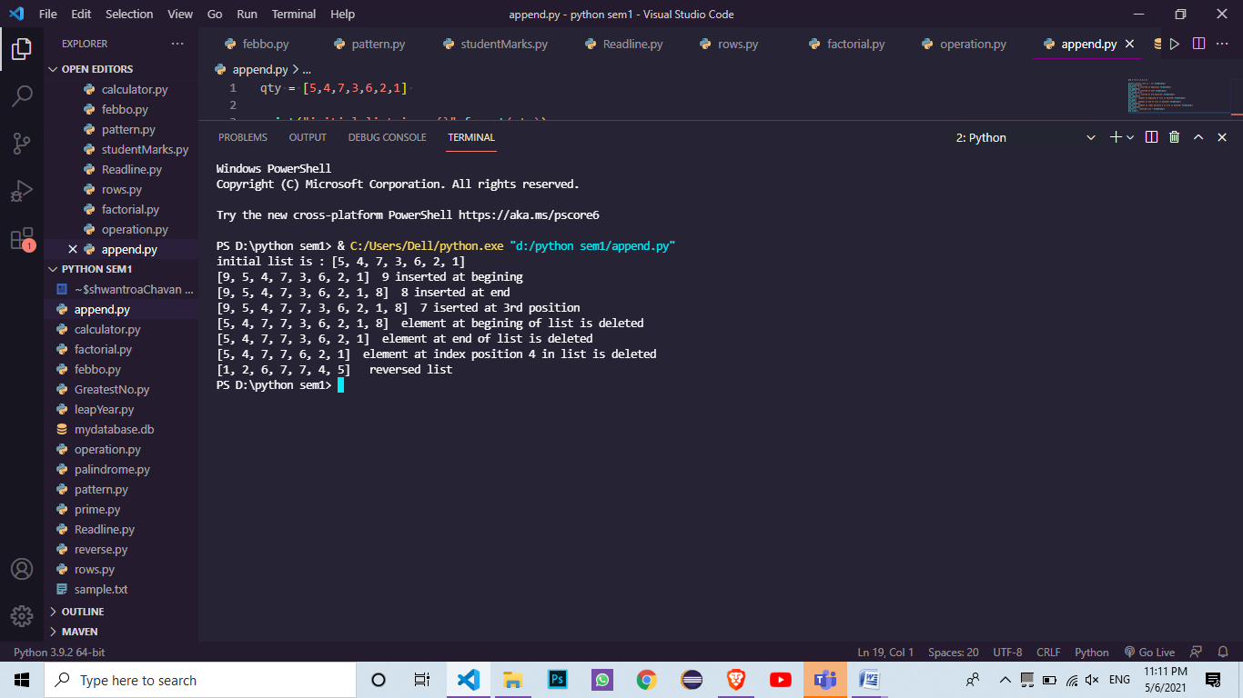

***Qus14 :- Create a dictionary for words and their meanings.***

***# Write functions to add a new entry (word: meaning) ,***

***# search for a particular word and retrieve meaning,***

***# given meaning find words with same meaning ,***

***# remove an entry, display all words sorted alphabetically.***

***# [Program must be menu driven]***

***Input:-***

import os

import json *#json exposes an API familiar to users of the standard library*

import difflib

from difflib import get_close_matches

data =json.load(open("D:\python sem1\data.json"))

c='y'

def extract(*word*):

                    word=word.lower()

                    if word in data:

                                        return data[word]

                    elif len (get_close_matches(word,data.keys())) > 0 :

                                       new=input("\nDid you mean %s ?\n\nEnter 'y' if yes.\n'n' if No\n"% get_close_matches)

                                       new=new.lower()

                                       if new =="y":

                                             return data[get_close_matches(word,data.keys())[0]]

                                       elif new=='n' :

                                                            print("\nsorry unfortunatly we don't have the meaning ")

                                       else:

                                        print("Type y/n not anything else .can you Be more Wrong")

                    else :

                                        return"the word entering is worng please try again."

Enter=input("Enter your Word :")

means=extract(Enter)

print(means)

Output:

